Home Learning Resources

Organisation/  Agency | Description of Resource | Where to Find It
PSHE Association  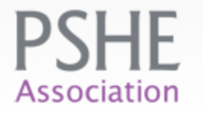 | Lots of free and some member resources that are suitable for home learning. | https://www.pshe-association.org.uk/curriculum-and-resources
EC Resources - TES  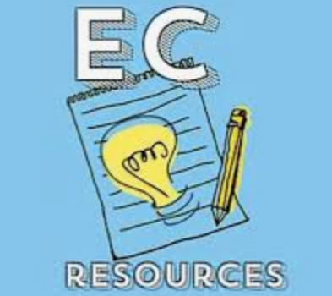 | Collection of free PSHE workbooks for the new 2020 Guidelines, suitable for home learning. | https://www.tes.com/teaching-resource/pshe-home-learning-pack-12268315
TES   | PSHE / SMSC / Citizenship / English / History - 30 Page Student Activity Pack. | https://www.tes.com/teaching-resource/covid-19-home-learning-pack-coronavirus-12267191
Education Freedom  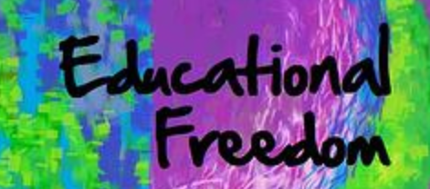 | Free resources from a number of organisations including British Heart Foundation, British Legion and Postal Museum. | https://educationalfreedom.org.uk/free-resources/
Open Learn   | Lots of fantastic free resources for children aged 13 and over. | https://www.open.edu/openlearn/free-courses/full-catalogue
DUOLINGO  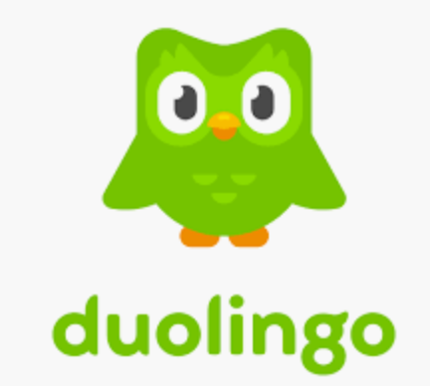 | A free to access learn a language site. Learn 30+ languages online with bite-size lessons based on science. | https://www.duolingo.com/
Home Education Resources  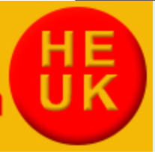 | A number of recommended home education websites/resources. Many of them are free. | https://www.home-education.org.uk/resources-educational.htm
Twinkl  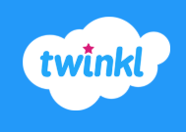 | Lots of free to download resource packs. | https://www.twinkl.co.uk/resource/t-he-770-free-home-education-resources-sample-pack
Art Hub for Kids   | Lots of videos lessons for making an array of art projects. | https://www.youtube.com/channel/UC5XMF3Inoi8R9nSI8ChOsdQ
Khan Academy   | Free science and Humanities resources and lesson plans. | https://www.khanacademy.org/science
BBC Bitesize  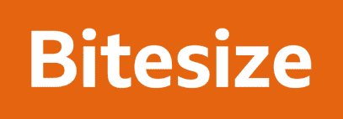 | Lots of free videos and helpful topics on a number of topics. | https://www.bbc.co.uk/bitesize
Quizlet   | Free education resources for KS1 – KS4. | https://quizlet.com/en-gb
Oxford Owl   | Educational resources and free eBooks to support children's learning at primary school and at home, from Oxford University Press. | https://www.oxfordowl.co.uk/

